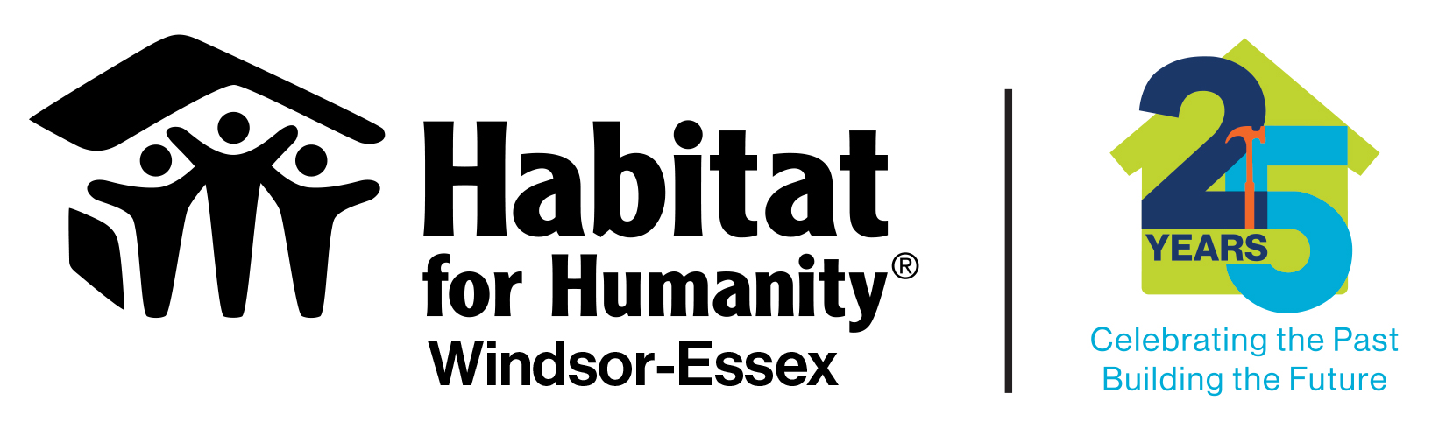

MEDIA RELEASE

Contact:
Fiona Coughlin, Executive Director/CEO Pamela Breault, Director of Operations
Habitat for Humanity Windsor-Essex Habitat for Humanity Windsor-Essex
519-969-3762 ext. 225 519-969-3762 ext. 229
226-788-9198 cell 226-788-9435 cell
fcoughlin@habitatwindsor.org pbreault@habitatwindsor.org

Habitat for Humanity Windsor-Essex breaks ground on two homes in Historic Sandwich Town

(Windsor, ON) September 9, 2023
Habitat for Humanity Windsor-Essex welcomed the community to celebrate the ground breaking of two homes in Sandwich Town on Saturday.
3356 and 3360 Baby Street will be the first two of five homes to be built in the Historic Sandwich Town neighbourhood. On Saturday, two future Habitat Homeowners turned sod in a ground breaking ceremony in preparation of the construction of their new, safe, affordable homes.
“Today’s announcement builds on the success of the partnership between the federal government and Habitat for Humanity,” said Irek Kusmierczyk, Member of Parliament for Windsor—Tecumseh and Parliamentary Secretary to the Minister of Employment, Workforce Development and Disability Inclusion, “Through our shared dedication and combined efforts, we amplify our impact and show how much farther we can go when we work with each other. Amazing things can happen when we join forces. We’re not just building houses but building better lives and stronger communities.”
In March 2023, the Government of Canada and Habitat for Humanity Canada announced an additional $25 million investment to build 500 new affordable homes across Canada over the next three years. This brings the total federal investment in Habitat for Humanity to $80.8 million through the Government of Canada’s National Housing Co-Investment Fund.
“Habitat’s model is unlike any other affordable housing option.” states Lindsay Lovecky, Board Chair, HFHWE. “Partner families help build their own homes and purchase them through a zero-interest mortgage geared to their income. This allows families to build equity for their future and helps reverse the cycle of poverty.” Lovecky adds.
“We are very excited to announce our Partnership on these build projects, with our Baby Street Build Sponsor, BK Cornerstone.” says Fiona Coughlin, CEO, HFHWE. “The housing crisis is a monumental challenge. Partnership is the key to tackling this challenge.” Coughlin adds.
Today, Habitat for Humanity Windsor-Essex (HFHWE) invited the media and public to attend the Ground Breaking Ceremony, for two solo parent families; Sam and his two children, and Adriana and her two children. These families represent the 84th and 85th families HFHWE have helped to provide a safe, decent, affordable, homeownership option.

#84
Sam is a dedicated father who loves his children more than anything in the world. His two kids, an 11-year-old daughter and an 8-year-old son, both have disabilities that require him to homeschool them full-time. Despite the challenges, Sam is determined to provide his children with the best possible education and a safe, nurturing environment.
Unfortunately, Sam's current living situation is far from ideal. He and his children live in an old, run-down house in a neighborhood that is known for its high crime rate. Worse still, there is a serious mold problem that poses a significant health risk to his children.
Sam advocates tirelessly for his children's rights, and is always on the lookout for new resources and support; and was thrilled to learn that through a Partnership with Habitat for Humanity Windsor-Essex, they would be able to build a new home for his family – one that is safe, affordable, and suited to their needs.
​#85
Adriana is a hardworking single mom who had been working at a local non-profit training organization for the past 14 years. She loves her job and is passionate about helping others. Dedicated to her career, Adriana is challenged to provide am affordable permanent home for her two children, a 10-year-old daughter and a 6-year-old son.
Their current rental is overcrowded, with the three of them sharing a small two-bedroom space. Adriana works hard but could not manage to find anything more suitable and still remain affordable.
​With the help of Habitat volunteers, Adriana and her children will be able to build their own home in a safe and secure neighborhood. The new home will have enough space for her family, with three bedrooms, a backyard, and a front porch. Adriana is thrilled to finally have a plan in place to provide a stable and secure home for her family.

Habitat for Humanity Windsor Essex
Founded in 1994, Habitat for Humanity Windsor-Essex is a non-profit community service organization working for a world where everyone has a safe and decent place to live. Our mission is to mobilize volunteers and community partners in building affordable housing and promoting home ownership as a means to breaking the cycle of poverty. For more information, please visit www.habitatwindsor.org

